Q. Change **FONT size, WIDTH and POSITION** of text box

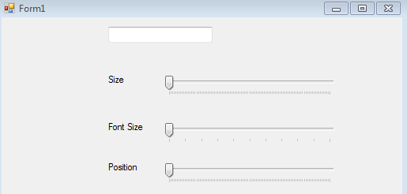

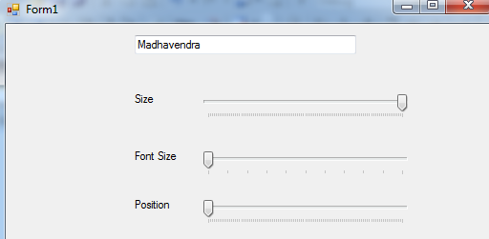

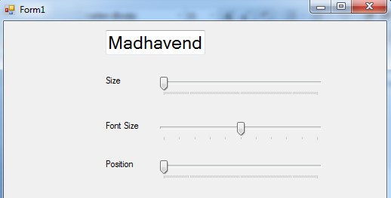

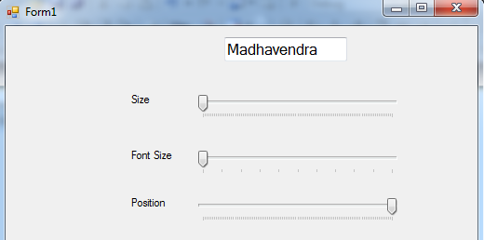

Public Class Form1

'Public initHeight As Integer

Public initWidth As Integer

Public initFontSize As Integer

Public initPosition As System.Drawing.Point

Private Sub Form1_Load(ByVal sender As Object, ByVal e As EventArgs) Handles MyBase.Load

'initHeight = TextBox1.Height

initWidth = TextBox1.Width

initFontSize = TextBox1.Font.Size

initPosition = TextBox1.Location

End Sub

Private Sub FontTrackBar_Scroll(ByVal sender As Object, ByVal e As EventArgs) Handles FontTrackBar.Scroll

TextBox1.Font = New Font(FontFamily.GenericSansSerif, 12.0F + CSng(FontTrackBar.Value), FontStyle.Regular)

End Sub

Private Sub SizeTrackBar_Scroll(ByVal sender As Object, ByVal e As EventArgs) Handles SizeTrackBar.Scroll

'TextBox1.Height = initHeight + SizeTrackBar.Value

TextBox1.Width = initWidth + SizeTrackBar.Value

End Sub

Private Sub PositionTrackBar_Scroll(ByVal sender As Object, ByVal e As EventArgs) Handles PositionTrackBar.Scroll

TextBox1.Location = New System.Drawing.Point(initPosition.X + PositionTrackBar.Value, initPosition.Y)

End Sub

End Class